**JAVASCRIPT CODEWITHHARRY CHANNEL**

Java Script is a dynamic interpreted programing language

It allows client-side scripting to create completely dynamic web applications and websites

**JAVASCRIPT:**

What is JavaScript?

It defines all the actions to be done on a web page.

It is object-oriented programming language which uses JIT complier

It is everywhere all the web browsers will be installed with it

JavaScript ranges from web development and mobile application etc.

JavaScript is very easy and compatible with html and CSS

What is JIT (just in time) compiler

Simple words it’s the combination of complier and interpreter

Identifies the hot or warm components of the code Ex: Repetitive code

Transforms the components into the machine code

Optimizes the machine code

Hot swap the previous implementation of the cod

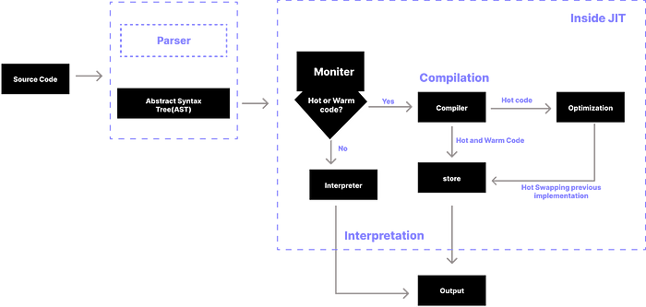

**History of the JavaScript:**

JavaScript founder was Brendan Eich

He invented JS in 1995

He was developed first Js engine spider monkey and it is still used by the Mozilla Firefox

Js Named was changed to mocha and live script but due to some trademarks its still continuing as JavaScript

Tools:

We need two things:

1. Text editor
2. Browser

How many ways we can write the JavaScript?

Three ways

1. Console
2. Script tag
3. External Js File

JavaScript Via Script tag

<script> Tag will write the JS code in html directly

Console.log() will print the output in the console of the browser